Name: Sapargali Temirlan
Group: SE-2403
Instructor: Kozhakhmet Zhaksylyk
PART 3 TASK 5
Deriverables
VulnerableVault.sol, Attacker.sol, FixedVault.sol, VulnerableAccess.sol, FixedAccess.sol are in their respective files.
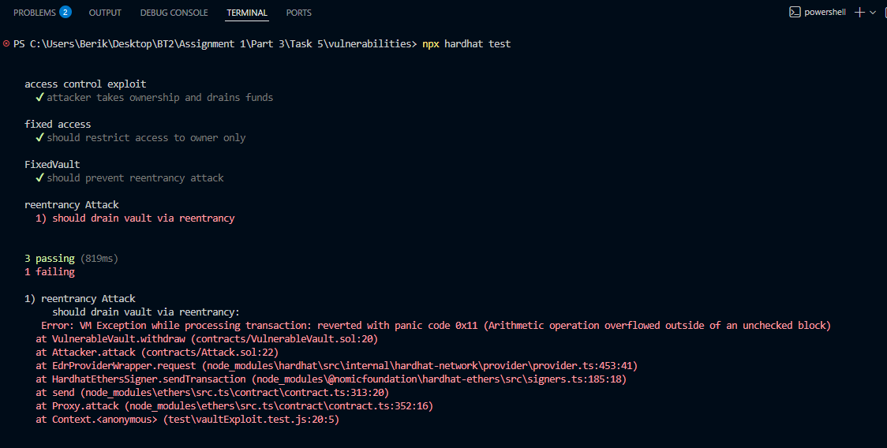
(Reentrancy attack fails with a error panic because it drains funds so much it goes into negatives)
Reentrancy Vulnerability
Description
A reentrancy attack occurs when an external call is made before updating internal state, allowing an attacker to recursively call the vulnerable function.
Root Cause
External call (call) executed before state update
No reentrancy guard
Impact
Complete draining of contract funds
Loss of user deposits

Exploit Flow
Attacker deposits ETH
Calls withdraw()
Fallback triggers recursive withdrawals
Funds drained before balance update
Remediation
Apply Checks-Effects-Interactions pattern
Use OpenZeppelin ReentrancyGuard

Access Control Misconfiguration
Description
Privileged functions lack access restrictions, allowing unauthorized users to execute critical operations.
Root Cause
Missing onlyOwner modifier
No role-based access control
Impact
Ownership takeover
Unauthorized fund withdrawal
Exploit Flow
Attacker calls setOwner()
Becomes owner
Calls withdraw()
Drains funds
Remediation
Use OpenZeppelin Ownable or AccessControl
Restrict sensitive functions with modifiers

